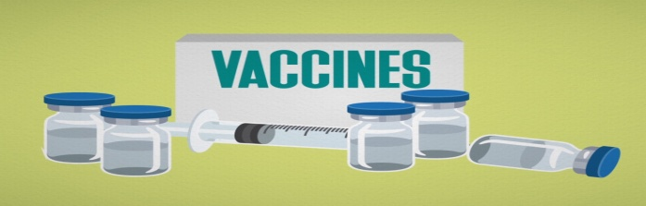
The importance of vaccinating your dog
Are vaccines really necessary?
Vaccinations help protect your pet from a number of potentially serious and even fatal diseases, like rabies. Not only that, vaccinations cost considerably less than the treatments available for the diseases pets are normally vaccinated against.

How do vaccinations work?
Vaccines contain viruses or bacteria that have been modified so they can’t cause disease. The vaccine stimulates the animal's immune system. If your animal is later exposed to that disease, the immune system will react quickly to destroy the disease-causing agent.
Why do puppies require a series of vaccines?
During the first few hours after birth, puppies ingest maternal antibodies contained in their mother's milk. These antibodies help protect the puppy from infectious diseases until its own immune system is more mature.
Unfortunately, maternal antibody also interferes with a vaccine's ability to stimulate the puppies immune system. To counteract this problem, veterinarians often administer a series of vaccines, usually beginning when the puppy is around six to eight weeks of age. Vaccination is then repeated at three- or four-week intervals until maternal antibody has waned, usually at around twelve weeks of age. In some cases (Rabies Vaccines) the initial vaccine is not given until maternal antibody has disappeared altogether (around 16 weeks).
How often do I need to vaccinate my adult dog?
At Stroud Veterinary Hospital we typically vaccinate every year with Rabies and DHLPP (Distemper, Hepatitis, Leptospirosis, Parvovirus, Parainfluenza) until they are 3 years of age then continue to do annual examinations but split up the vaccines (one year would be Rabies and then the next DHPP) until age 10. After 10 years we vaccine based on life style of owners and pets. Leptospirosis and Bordetella bronchioseptica are bacterial problems, and these vaccines must be given every year to be effective.
What do you vaccinate against?
Canine Distemper
- Viral disease that affects the respiratory, gastrointestinal and nervous system
- Airborne, main source of transmission is respiratory secretions
- Causes coughing, sneezing, nose and eye discharge, fever, loss of appetite, vomiting, diarrhea, listless and seizures
- Is sometimes fatal, and can have lifelong effects if the animal recovers.
- Commonly carried by raccoons

Canine Hepatitis

- Viral disease, affects the liver, kidneys and cells lining blood vessels
- Spread through the inhalation or ingestion of infected feces, urine or saliva
- Causes high fever, thirst, inflammation of nose or mouth, diarrhea, abdominal pain and tenderness, vomiting, loss of appetite, hemorrhage and depression
- Permanent liver damage is common, and is frequently fatal in unvaccinated animals.

Parvovirus

- Viral infection, affects mostly gastrointestinal tract, can progress quickly to system failure and death
- Spread through contact with infected dogs blood, feces or vomit, and lasts for 6 months or more in the environment.
- Causes severe bloody diarrhea, fever, vomiting, loss of appetite. If they do recover, dogs often have permanent problems with food digestion.

Parainfluenza

- Viral infection of the respiratory tract
- Spreads quickly among dogs in close quarters
- Causes a dry hacking cough, loss of appetite, depression, runny nose and eyes

Coronavirus

- Affects the gastrointestinal tract
- Spread through contact with infected blood, vomit or feces
- Causes occasional vomiting, fever and diarrhea
- Is a mild and self-limiting disease, puppy mills often vaccinate to minimize diarrhea in puppies

Leptospirosis

- Bacterial disease
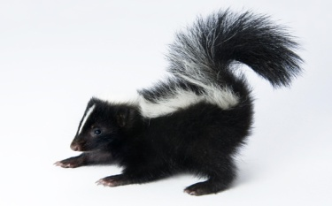
- Spread through contact with nasal secretions, urine or saliva of infected animals (usually wildlife like skunks and raccoons) contact with infected urine in shallow ponds, puddles and water dishes
- Causes fever, vomiting, diarrhea, urinary infections, loss of appetite and listlessness
- Humans can also be infected- for example, when cleaning up "accidents" of infected pets
- Early signs are not always apparent, is curable with antibiotics BUT often causes permanent liver/kidney damage before it resolves
- Occasionally will manifest as sudden death - in animals AND people

Rabies

- Always fatal!
- Infection of the central nervous system
- Spread through the bite or scratch of an infected animal - can take up to 6 months to show signs
- Humans can be affected
- Two phases of the disease
- Excitatory phase/furious rabies: Restlessness, irritable, unprovoked biting, sensitivity to noise
- Paralytic phase/dumb rabies: Paralysis, cramps and swallowing difficulties, excessive salivation

Bordetella or Kennel cough

- Affects the respiratory tract
- Airborne, Highly contagious - no direct contact needed, and lives in air droplets for 15min or more
- Causes persistent cough, sneezing and retching - but is generally (eventually!) self limiting
- Vaccine is sometimes done with nasal or oral drops for faster protection, especially the first dose
- Many kennels and doggy daycares require this vaccine before admitting dogs

https://www.ovma.org/pet-owners/basic-pet-care/pet-health-101/

