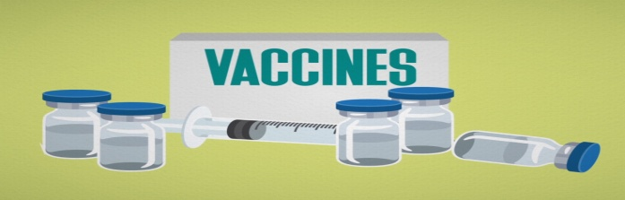
The importance of Vaccinating your cat
Why does my cat need to be vaccinated?
The immune system plays a pivotal role in maintaining your cat's health. One of the most important functions of this complex system of specialized cells and molecules is to protect cats from disease and infection caused by viruses, bacteria, and a host of other microbes and parasites.
Vaccines help prepare your cat's immune system to fend off invasion by a particular disease-causing organism. Vaccines contain antigens, which to the immune system "look" like the organism but don't, ideally, cause disease. When a vaccine is administered, the immune system mounts a protective response. Then if your cat is subsequently exposed to the disease-causing organism, its immune system is prepared to either prevent infection or reduce the severity of disease.
Why do kittens require a series of vaccinations?
During the first few hours after birth, kittens ingest maternal antibodies contained in their mother's milk. These antibodies help protect the kitten from infectious diseases until its own immune system is more mature.
Unfortunately, maternal antibody also interferes with a vaccine's ability to stimulate the kitten's immune system. To counteract this problem, veterinarians often administer a series of vaccines, usually beginning when the kitten is around six to eight weeks of age. Vaccination is then repeated at three- or four-week intervals until maternal antibody has waned, usually at around twelve weeks of age. In some cases (Rabies Vaccines) the initial vaccine is not given until maternal antibody has disappeared altogether (around 16 weeks).
How often do I need to vaccinate my adult cat?
You may have heard about current controversies regarding vaccinating cats. Some researchers believe we do not need to vaccinate annually for most diseases. But how often we should vaccinate for each specific disease in adult animals has not yet been determined. We do not know how long the protection from a vaccine lasts. At Stroud Veterinary Hospital we typically vaccinate every year with both Rabies and FVRCP (Feline Viral Rhinotracheitis, Calicivirus, Panleukopenia) until they are 3 years of age then continue to do annual examinations but split up the vaccines (one year would be Rabies then the next FVRCP) until age 10. After 10 years we vaccinate based on lifestyle of the patients. Feline Leukemia is also added to the vaccines if the cat is outdoors.
My cat is indoors only, why do I need to vaccinate?
Indoor cats are still at risk of being exposed to certain diseases. Airborne viruses can easily pass through open windows and infect your cat. Stray cats in the neighborhood can wander up to screens and can come into contact with your indoor cat. If you handle infectious cats unknowingly, you can bring in pathogens (disease causing viruses and bacteria) on your clothes and unwashed hands. For owners who enjoy gardening, you can track pathogens from stray cats in your garden into your home on your shoes. There is also a risk of wildlife (especially bats) entering your home that may be infected with rabies. Keeping your cat indoors will lower the chances of being exposed to certain viral and bacterial infections but vaccines are still highly recommended to keep your pet happy and healthy!
What do you vaccinate against?
Feline Panleukopenia or Feline Distemper
- Viral Disease, affects the intestinal tract and bone marrow
- Airborne Virus, spread through contact with an infected animal or places an infected animal has been
- Causes vomiting, severe diarrhea, fever and death
Feline Immunodeficiency Virus (FIV)
- Viral infection, weakens your cats immune system
- Similar in nature to HIV in humans
- Present in bodily fluids- typically passed by direct biting
- FIV positive kittens may be born from infected mothers
- Causes swollen glands, depression, loss of appetite, weight loss, mouth sores, and recurrent infections
Feline Infectious Peritonitis (FIP)
- Viral disease, interacts with the kittens immune system
- Most common route of infection is oro-nasal (mouth and nose), kittens may be infected before birth
- Causes rough hair coat, fever, loss of appetite, neurological signs, labored breathing, "pot-belly"
- Infected cats may not show signs for a lengthy period of time (years!), and then suddenly turn ill
Feline Leukemia Virus (FeLV)
- Viral infection, usually deadly, inhibits the immune system and results in various types of cancer and other chronic diseases
- Present in bodily fluids- typically passed by direct contact through licking, biting and sneezing
- Causes depression, fever, loss of appetite, anemia, swollen neck glands and recurring infections
- Can be infected for long periods of time before showing symptoms
- Kittens can be infected before birth, but most commonly it is transmitted through contact with stray or feral cats. Indoor cats generally do not need to be vaccinated for this disease
Rabies
- It is a legal requirement in Innisfil to have your pets vaccinated for this disease
- Always fatal
- Infection of the central nervous system
- Humans can be affected
- Spread through the bite of infected animal
- Dr. Hatch has personally had two (different) cases of indoor cats being exposed by exposure to a bat that got into the house
- Two phases of the disease 1) Excitatory phase/furious rabies: restless, irritable, unprovoked biting, sensitivity to noise 2) Paralytic phase/dumb rabies: Paralysis, cramps and swallowing difficulties
Upper Respiratory Disease
- Airborne viral disease, affects the respiratory system
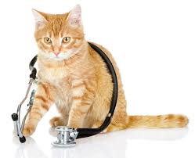
- Causes flu like symptoms, nasal and ocular discharges, ulcers in the mouth, on the tongue or in the throat
http://www.vet.cornell.edu/fhc/health_information/vaccines.cfm

